PRACTICAL – 1
Java Environment Setup with JDK 21

Student Details
Name: Harsh raj
Roll No.: 25scs1003005511
Course/Branch: B. tech CSE
Date: 10th Aug

Objective
To create, compile, and execute a basic Java program named HelloWorld.java, understand the Java program execution process, and study the basic structure of a Java program.

Tasks
1.Writing of Source Code (.java file)
2.Compilation of the source code into (.class file)
3.Execution of the bytecode

Writing of Source Code (.java file)
Create a Java source file named HelloWorld.java and write the following program:
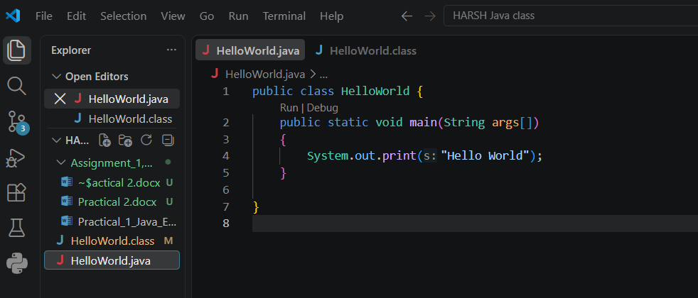

Compilation of the source code into (.class file)
Open Command Prompt or the VS Code Terminal in the folder containing HelloWorld.java and execute the following command:
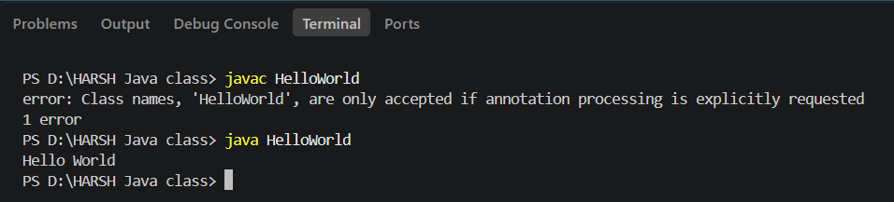
Generated .class File
After successful compilation, the folder contains HelloWorld.class. This file contains Java bytecode that can be executed by the Java Virtual Machine (JVM).
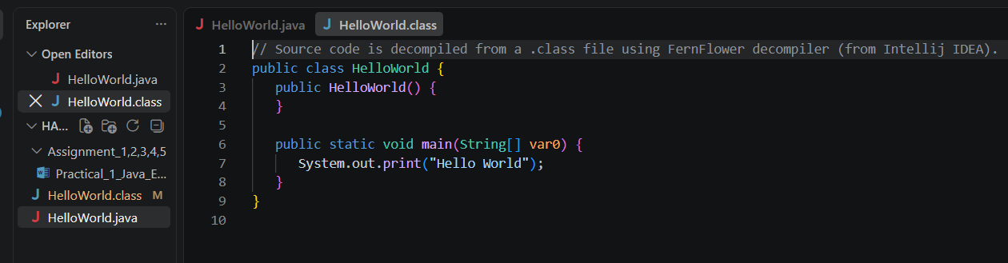

Execution of the bytecode
Run the compiled program using:


Brief Answers

1. What is a Java program?
A Java program is a set of instructions written in the Java programming language to perform a specific task. The source code is stored in a .java file, compiled into bytecode, and then executed by the JVM.

2. What is the purpose of the main() method?
The main() method is the starting point of execution for a standalone Java application. The JVM begins execution from public static void main(String[] args).

3. What is the difference between javac and java?
javac is the Java compiler used to convert a .java source file into a .class bytecode file. The java command launches the compiled program and the JVM executes its bytecode.

Java Program Structure – Detailed Explanation
The basic structure of a Java program can be understood using the HelloWorld program. Each part of the program has a specific purpose:
public class HelloWorld – Declares a public class named HelloWorld. The public class name matches the source file name HelloWorld.java.
{ } – Curly braces define the beginning and end of the class and method blocks.
public static void main (String args[]) – Defines the main method, which is the entry point of execution for a standalone Java application.
public – An access modifier that allows the JVM to access the main method.
static – Allows the JVM to call the main method without creating an object of the class.
void – Indicates that the main method does not return a value.
String[] args – Stores command-line arguments supplied to the program.
System.out.println() – Displays the specified message on the console and moves the cursor to the next line.
"Hello, World!" – The string that is displayed as the output of the program.
; – A semicolon marks the end of a Java statement.

Flow of Java Program Execution
HelloWorld.java
|
| javac HelloWorld.java
v
HelloWorld.class
|
| java HelloWorld
v
JVM executes bytecode
|
v
Output: Hello, World!

Conclusion
The Hello World Java program was created, compiled, and executed successfully. The practical demonstrates the complete basic execution process of a Java program: source code is written in a .java file, compiled by javac into a .class bytecode file, and executed by the JVM using the java command.

